November 24

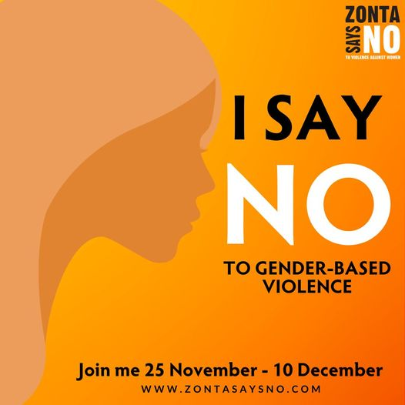

Join us this November 25 - December 10 to say NO to gender-based violence through the #ZontaSaysNO to Violence Against Women campaign.
Share this photo on your profile to show that, through your actions, you will #BuildABetterWorld for women and girls.
www.zontasaysno.com zontaclubofottawa
https://zontasaysno.com/ https://zontaottawa.ca/

November 25

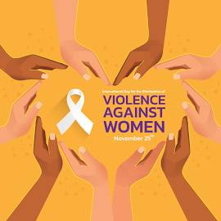
On February 7, 2000, the United Nations officially designated November 25 as the International Day for the Elimination of Violence Against Women. In Canada, the 16 Days of Activism Against Gender-based Violence is an annual international campaign runs from November 25 to December 10, Human Rights Day.
This campaign started in 1991 to encourage everyone to call out and speak up on gender-based violence, and to renew our commitment to ending violence against women, girls, and 2SLGBTQI+ individuals.
Our club is joining the Zonta Says NO to Violence Against Women campaign, @ZontaSaysNO, by sharing information in a post each day. Please like and share our posts to help spread the word! #ZontaSaysNO www.zontasaysno.com

November 26

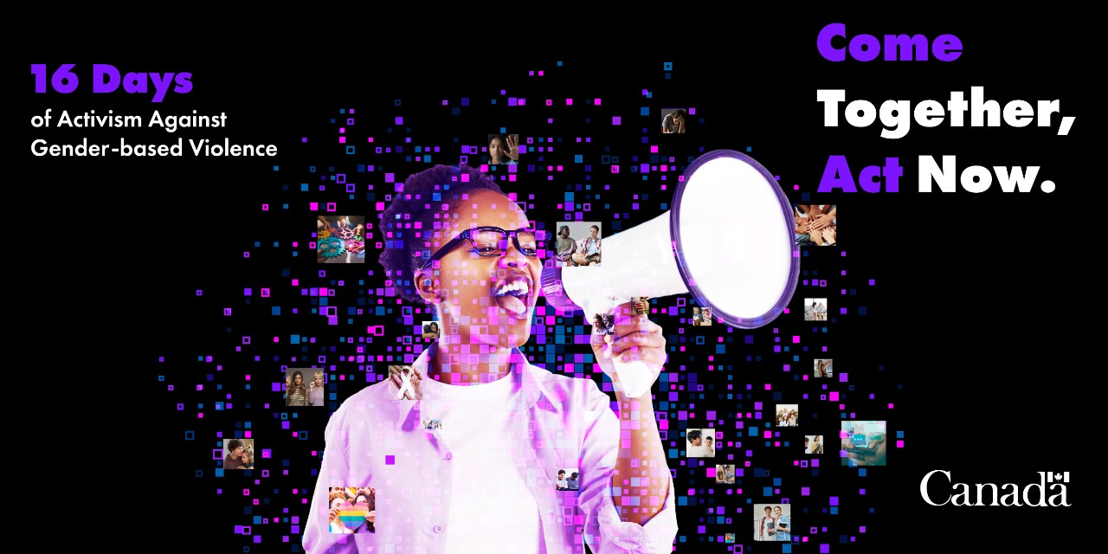
To commemorate this year’s 16 Days campaign, we want to share with you this excellent website of resources offered by Women and Gender Equality. Gender-based violence is a serious issue, and learning about it is the first step to making a difference. This website enables you to explore clear and easy-to-follow workbooks, important facts, powerful infographics, and more to help answer your questions.

November 27

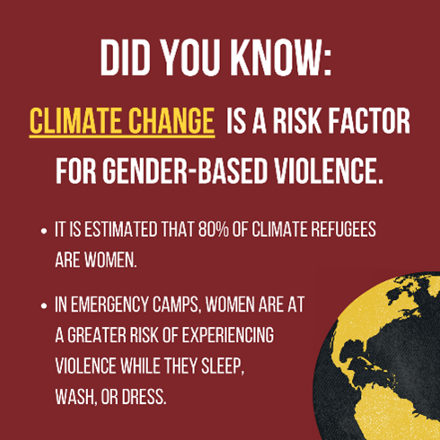
The Zonta Club of Ottawa, Canada plans to launch a climate justice education program for our members and our networks. As a jumping off point, we are learning through reading All We Can Save: Truth, Courage, and Solutions for the Climate Crisis together and discussing what our action steps could be through an All We Can Save Circle. Stay tuned for more details in the coming months and reach out to us via Facebook Messenger if you’re interested in joining us!

November 28

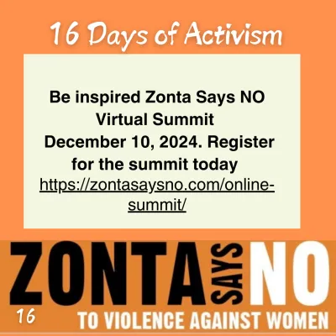

Join Zonta International, our club, and our Zonta friends from around the world in participating in this upcoming virtual summit! Throughout the day, there will be three sessions featuring three amazing speakers. Each speaker will share their own expertise and perspective and there will be time for questions from participants.

November 29

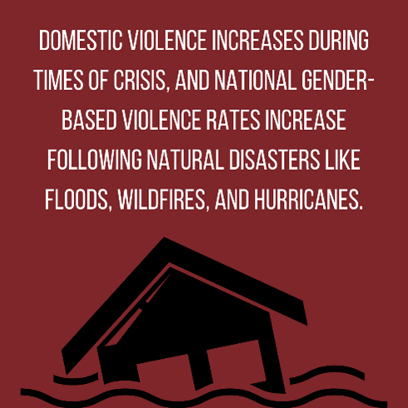

As a historic hurricane season draws to a close, its impacts and the impacts of other climate-driven disasters continue to be felt. In all countries, gender-based violence is a factor post-disaster. This often stems from stress due to financial concerns, disaster-trauma heightened mental health issues, and increased substance abuse, to name a few factors. (Source: The Center for Disaster Philanthropy)

November 30

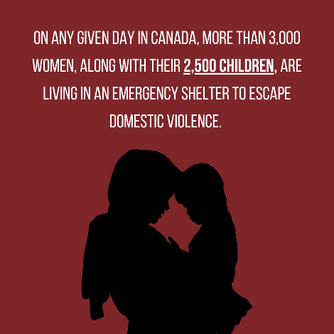

Our club supports many like-minded organizations working to provide shelter for the city’s most vulnerable women, including Cornerstone Housing for Women, Interval House, Carty House, and The Alliance to End Homelessness Ottawa.

December 1

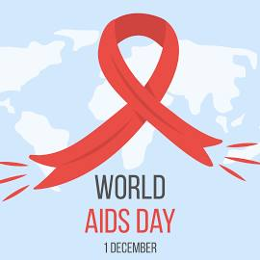

Today is the 36th World AIDS Day. This year’s theme is to speak up for health equity. Help us ensure that everyone, everywhere, has the right to quality healthcare services in the fight against HIV and AIDS (Source: UN AIDS)

December 2

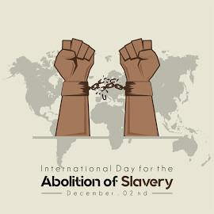

Today is International Day for the Abolition of Slavery. This day focuses on eradicating contemporary forms of slavery, such as trafficking in persons, sexual exploitation, child labour, and forced marriage.
Female victims are three times more likely to be subjected to physical or extreme violence at the hands of traffickers than male victims. Detected victims of trafficking are comprised of 42% women and 18% girls.
For information about how you can help, visit the Ottawa Coalition to End Human Trafficking’s website. The Canadian Centre to End Human Trafficking https://www.canadiancentretoendhumantrafficking.ca/

December 3

Image to follow: Photo of Renuka and Cindy with Carty House representative and our cheque
Today is #GivingTuesday, a day to come together in support of causes that are important to us. GivingTuesday promotes the concept of "generosity not as a benevolence that the haves show to the have-nots but rather an expression of mutuality, solidarity, and reciprocity." (Source: The GivingTuesday organization)
This year, the Zonta Club of Ottawa reflects this concept through a contribution to Carty House. As the only homes dedicated to female refugees in Ottawa, Carty House’s locations provides a safe space for refugee women to live, grow, build a community, and settle into their new lives in Canada.
On this day of giving, we invite you to become a donor to support our efforts.
#GivingTuesdayCA

December 4

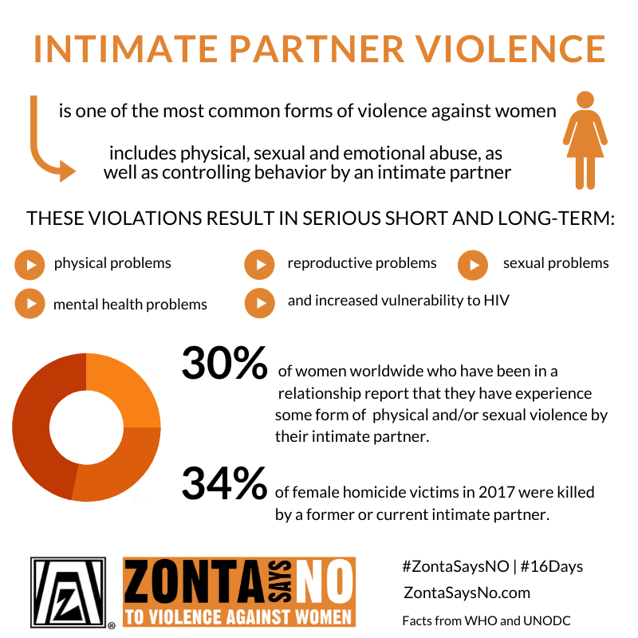

If you are fortunate to be in a loving relationship with your partner, you may wonder why women stay in abusive relationships. Too often, people assume that, if a woman is in an abusive relationship, she is making a choice to stay and has the power to end the abuse if she just leaves. For more information, we invite you to consult this Canadian Women’s Foundation’s fact sheet and learn how to be a Signal for Help Responder.

December 5

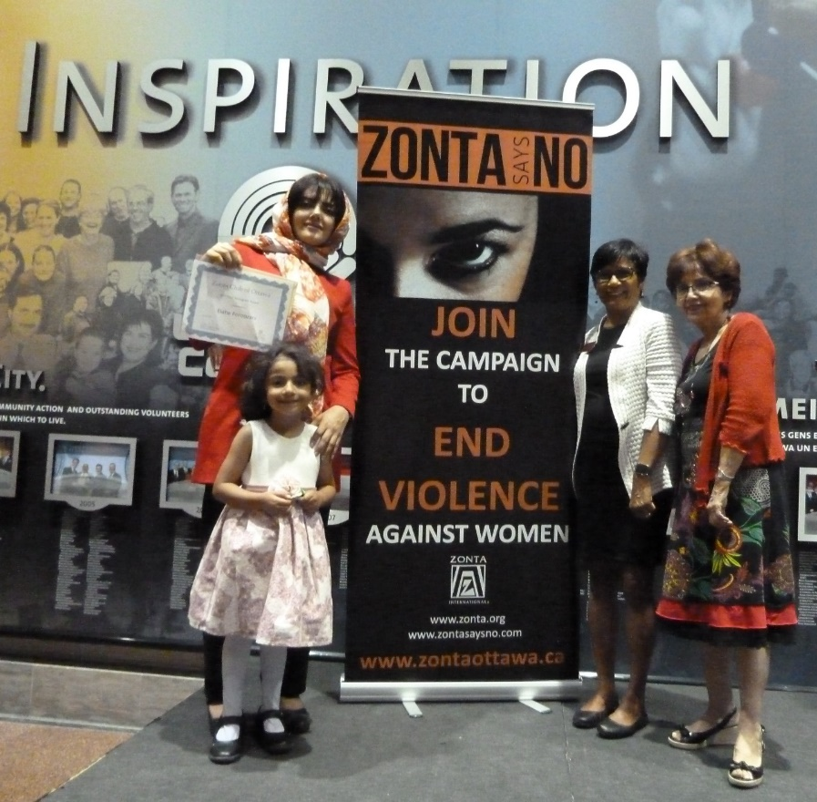

Today is International Volunteer Day, a global celebration of volunteers. It takes place every year on December 5 to shine a light on the impact of volunteer efforts everywhere. Volunteers are leading social change around the world, and our volunteer club is no exception.
Our advocacy to end gender-based violence, our annual awards and bursaries program for girls and women in the Ottawa-Gatineau region, and our upcoming climate justice education program are but a few examples. For more information, reach out to us via Facebook Messenger and visit our website.

December 6

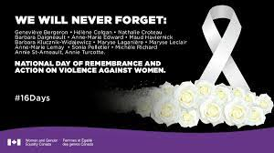
It has been more than 30 years since the murder of 14 young women at Polytechnique Montréal (December 6, 1989). This act of violent misogyny shook our country and led Parliament to designate December 6 as The National Day of Remembrance and Action on Violence Against Women.
Join us today in remembering.


National Day of Remembrance and Action on Violence Against Women

This year marks 35 years since the tragedy at L’École Polytechnique in Montreal. We remember the 14 women taken that day and honour the countless lives lost to femicide throughout Ottawa and beyond.

Join us at 6 PM at the Women's Monument in Minto Park (102 Lewis St, Ottawa). This year’s theme, 'Call It Femicide: Bridging the Local to Global,' reminds us that our efforts to end gender-based violence resonate worldwide.

#ORCCsupports #Ottawa #CommunityVigil #Community #CallItFemicide ##EndGBV

Join us today in remembering.

December 7

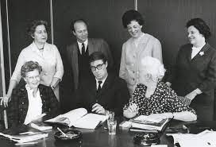
(Royal Commission on the Status of Women in Canada: Dominion Wide Photographs Limited, Library and Archives Canada, 1971-191 NPC)
Today marks the 54th anniversary of the Royal Commission's groundbreaking Report on the Status of Women in Canada. Created in 1967, this Royal Commission was a response to a months-long campaign by a coalition of 32 women’s groups calling on the federal government to advance equality for women.
The resulting report provided an overview of the status of women and made 167 recommendations to the federal government for reducing gender inequality.

The Zonta Club of Ottawa empowers women and girls through service and advocacy. For more information, contact us via Facebook Messenger and visit our website.

The 68th session of the Commission on the Status of Women (CSW68) will take place in New York from March 11–22, 2024. The theme for this year's session is to accelerate gender equality and women's and girls' empowerment. The session will include representatives from UN Member States, UN entities, and non-governmental organizations (NGOs).

The Royal Commission on the Status of Women in Canada (RCSV) was established in the 1960s to address issues affecting women in Canada. The commission's 1970 report included 167 recommendations on a range of topics, including:

Women in the economy
Education
Women in the family
Taxation and childcare allowances
Poverty
Participation of women in public life
Immigration and citizenship
Criminal law and women offenders

From left to right: John Humphrey, Lola M. Lange, Jeanne Lapointe, Florence Bird, Jacques Henripin, Elsie MacGill, and Doris Ogilvie. Retrieved from http://www.larevolutiontranquille.ca/en/the-committee-on-bird.php.

https://www.canada.ca/en/women-gender-equality/commemorations-celebrations/royal-commission-status-women-canada.html

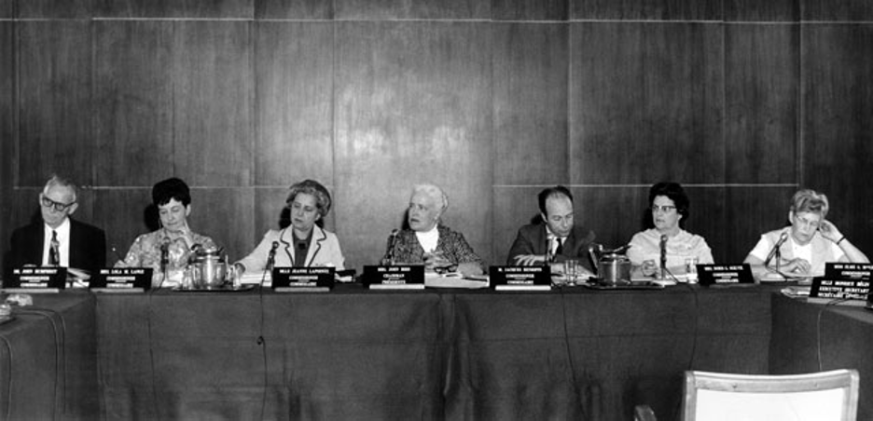

December 8

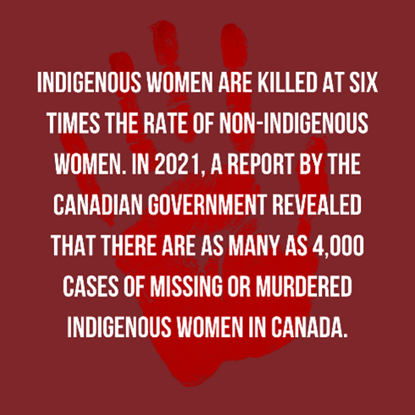

As if the disproportionate murder rate of Indigenous women as compared with non-Indigenous women weren’t unjust enough, Statistics Canada has shown there’s a disparity in the way homicide cases involving Indigenous women and girls are handled in the Canadian legal system. People accused of killing Indigenous women are less likely to be charged with first-degree murder. (Source: Statistics Canada)

The Native Women’s Association of Canada 's website offers information on how you can join the movement to have no more missing or murdered Indigenous women and girls in Canada.

December 9

As we near the end of the 16 Days of Activism campaign, we invite you to join the movement to prevent gender-based violence. Add your voice to ours in calling for the violence and the silence to end. Here are some ways you can help:
• Amplify our messages on Facebook and consider joining our club.
• Become a donor to support our efforts.
• Write to your provincial MPP and city councillor’s office to demand more significant funding for organizations directly supporting survivors.
• Check out and share campaigns, such as DRAW THE LINE, that can help bystanders identify and intervene when necessary

December 10

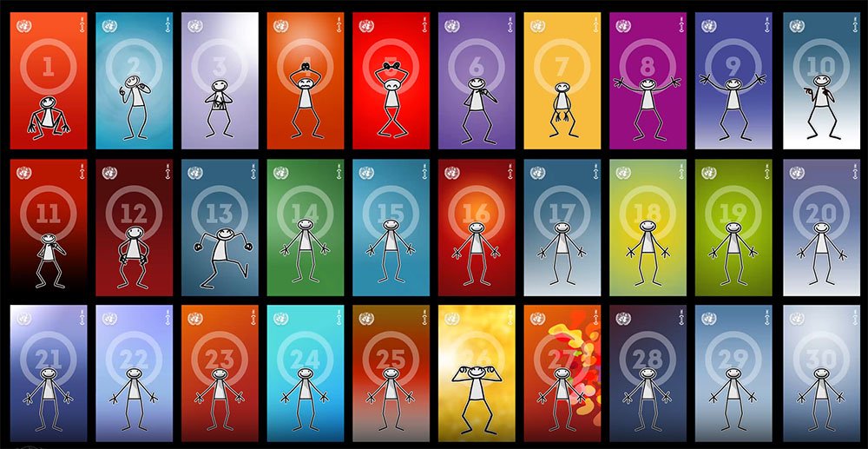

Today marks the 76th anniversary of one of the world's most groundbreaking global pledges: the Universal Declaration of Human Rights. This landmark document enshrines the inalienable rights that everyone is entitled to as a human being - regardless of race, colour, religion, sex, language, political or other opinion, national or social origin, property, birth or other status. Did you know it was authored by Canadian legal scholar John Humphrey?
The Zonta Club of Ottawa supports the Declaration and invites you to join us in fighting the discrimination that many women and girls still face based on sex and gender. Contact us via Facebook Messenger or visit our website to learn more about our local and global efforts.

November 27 (Alternate wording)

The Zonta Club of Ottawa, Canada plans to launch a climate justice education program for our members and our networks. We are first educating ourselves by participating in local events, including those of Ecology Ottawa. Stay tuned for more details in the coming months and reach out to us via Facebook Messenger if you’re interested in joining us in our learnings!

